**

**Softech** **Solutions Inc.**

[www.softechsolutionsgroup.com](http://www.softechsolutionsgroup.com)

[saney.alam@softechsolutionsgroup.com](mailto:saney.alam@softechsolutionsgroup.com%20)

# A Complete Selenium Guide

Selenium WebDriver Navigation Commands

***Lecture Notes***

Selenium WebDriver Navigation Commands

After successfully running our first test case on Firefox Browser now we are stepping towards grasping the essential **Browser Navigation Commands** in Selenium. Thus we are going to discuss about various navigation commands that we would be using in our day to day automation testing. The navigate interface exposes the ability to move backwards and forwards in the browser’s history.

To access the navigation’s method, just type **driver.navigate().**. The intellisence feature of eclipse will automatically display all the public methods of *Navigate Interface* shown in the below image.

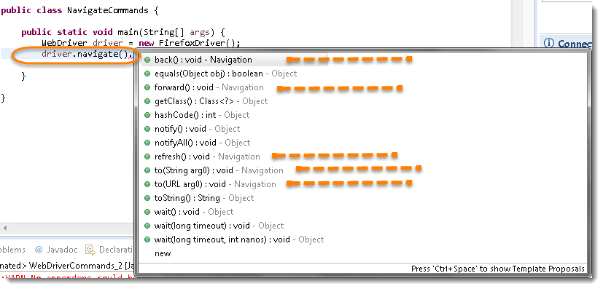

**Note:***Only methods which are followed by Navigation keyword are belongs to navigate. Rest followed by Object keyword are the generic methods gets from Object Class in Java. You will find these methods for every object of java language.*

***Navigate To Command***

***to (String arg0) : void*** – This method Loads a new web page in the current browser window. It accepts a String parameter and returns nothing.

Command – ***driver.navigate().to(appUrl);***

It does exactly the same thing as the **driver.get(appUrl)**method. Where appUrl is the website address to load. It is best to use a fully qualified URL.

***Forward Command***

**forward() : void** – This method does the same operation as clicking on the **Forward Button** of any browser. It neither accepts nor returns anything.

*Command* – **driver.navigate().forward();**

Takes you forward by one page on the browser’s history.

*driver.navigate().forward();*

## ***Back Command***

**back() : void** – This method does the same operation as clicking on the **Back Button** of any browser. It neither accepts nor returns anything.

*Command* – **driver.navigate().back();**

Takes you back by one page on the browser’s history.

*driver.navigate().back();*

## ***Refresh Command***

**refresh() : void** – This method **Refresh** the current page. It neither accepts nor returns anything.

*Command* – **driver.navigate().refresh();**

Perform the same function as pressing F5 in the browser.

*driver.navigate().back();*